The following is an introductory guide to starting to use/learn R/R Studio. R Studio contains tutorials that can help you practice these basic skills as well. Becoming comfortable with these basics will help you continue on with R, and the many packages available, easier. The goal here is to learn to “walk”. Remember that R IS CASE SENSITIVE, and character strings must be enclosed in single or double quotes.
- R Studio/R Basics
  - What Is/Definitions
  - Importing Data
  - Working with Packages
    - Creating Objects (Assignment Operator):
    - Calling Functions:
  - Manipulating Data Structures
    - Creating Data Frames
    - Tibbles
    - Filter
    - Pipes %>%
    - Boolean operators - &(and), |(or), !(not), xor(exactly or)
  - Organizing Data
    - Select
    - Arrange
    - Mutate
  - Miscellaneous
    - Plotting
    - Help help()
    - Keyboard Shortcuts in RStudio

What Is/Definitions
- Data Frame (df): A rectangular collection of variables (in the columns) and observations (in the rows). A data frame is a table or 2 dimensional array like structure. Each columns has one variable type and each row has one set of values from each column. rows=observations, columns=variables
  - Row names need to be unique, non empty column names, numeric, factor or char type.
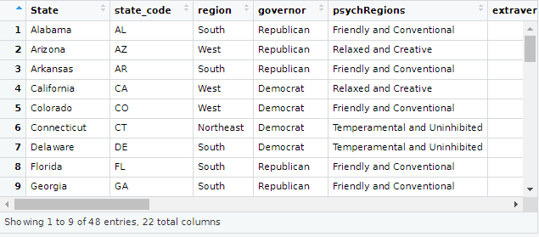
- Tibble (fancy data frame that's easier to read): “Tibbles are data frames that are lazy and surly: they do less (i.e. they don’t change variable names or types, and don’t do partial matching) and complain more (e.g. when a variable does not exist). This forces you to confront problems earlier, typically leading to cleaner, more expressive code. Tibbles also have an enhanced print() method which makes them easier to use with large datasets containing complex objects.” Rather than printing the whole data frame, tibbles only display the first few rows (typically 10), only one page at a time, and shows data types (int, char, etc).
  - To create a tibble from a data frame, use as_tibble(df) where df is the name of your data frame. It will return a tibble version of a dataframe to make it a bit easier to see the data.
  - To learn more about tibbles and how to use them R for Data Science is an online book that is also accessible via the R Studio IDE.
  - 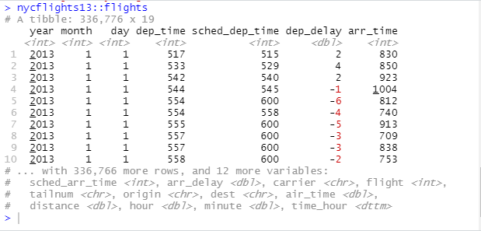
- Data Wrangling: The process of cleaning and unifying messy and complex datasets for easy access and analysis. Cleaning means fixing or removing incorrect, corrupted, incorrectly formatted, duplicated, or incomplete data.
- Data Exploration is the art of looking at your data, rapidly generating hypotheses, quickly testing them, then repeating again and again and again. The goal of data exploration is to generate many promising leads that you can later explore in more depth.
- Packages: R packages are collections of functions and data sets developed by the community. They are an ideal way to package and distribute R code and data for re-use by others. A package only needs to be installed once, but must be loaded in each new session with the library command. Popular packages include the tidyverse, dplyr, and ggplot2, although there are thousands to choose from.
- RDocumentation - essentially a search engine for R packages, not only a website but also a package itself https://www.rdocumentation.org/

Importing Data
- read_csv() reads comma separated (CSV) files
- read_csv2() reads semicolon separated files (this is common in countries where the comma is used as the decimal place)
- The Haven package reads SPSS, Stata, and SAS files
- readxl - reads excel files (both .xls and .xlsx)
- DBI, along with a database specific backend package (e.g. RMySQL, RSQLite, RPostgreSQL, etc.) allows you to run SQL queries against a database and return a data frame
- For hierarchical data (JSON, XML, etc.) use:
  - jsonlite for json
  - xml2 for XML
- For other file types, try the R data import/export manual and the rio package

Working with Packages
- Install/Uninstall: install.packages()
  - Type the name of the package inside the parenthesis (ex: tidyverse)
  - Multiple packages can be installed at once with install.packages(c("EIAdata", "gdata", "ggmap", "ggplot2"))
  - NOTE: Installation may take some time depending on your connection and device especially if you're using Linux
  - Installation is NOT the same as loading a package. Once a package is installed it remains in R Studio until/unless it is removed.
  - DO NOT remove packages unless it's not playing nicely with other packages. In that case, use remove.packages(package)
- Load/Unload Packages: library()
  - This loads the package for the current session. It must be reloaded each new session (it will remain installed however).
  - detach("packagename", unload=true) will unload a package for the session.
- Updating a Package: update.packages()
  - Leaving the parentheses empty will update all packages. Alternatively, you may type a specific package in the parenthesis to update only that one.
  - Updating regularly is recommended to avoid unexpected errors. Packages do not update automatically, even when you install a new version of R.
  - R Studio Tools also contains a "Check for Package Updates" option. You can update all or only selected packages.
    - 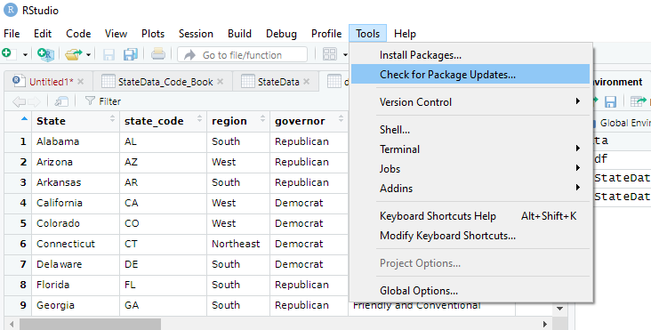
    - 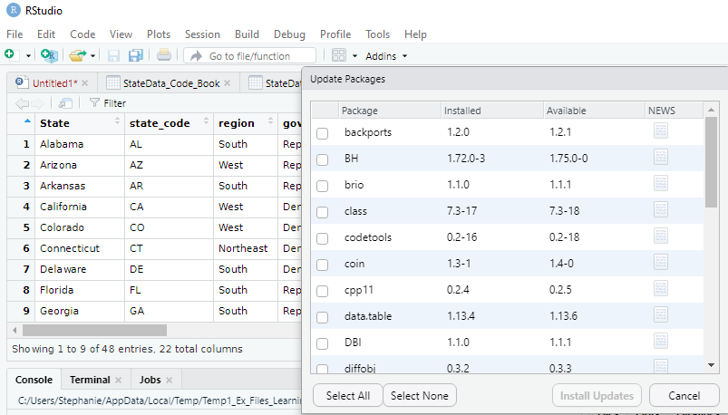

Creating Objects (Assignment Operator):
- To create an object, give it a name followed by the assignment operator (←) and the value we want to give it. We can rename any variable, including an entire data frame, this way as well.
- Object names must start with a letter, and can only contain letters, numbers, the underscore, and the period.
- Examples: df ← StateData , state ← df
  - Calling df would now return State Data, and state would return the data that was assigned to df.
  - See image: 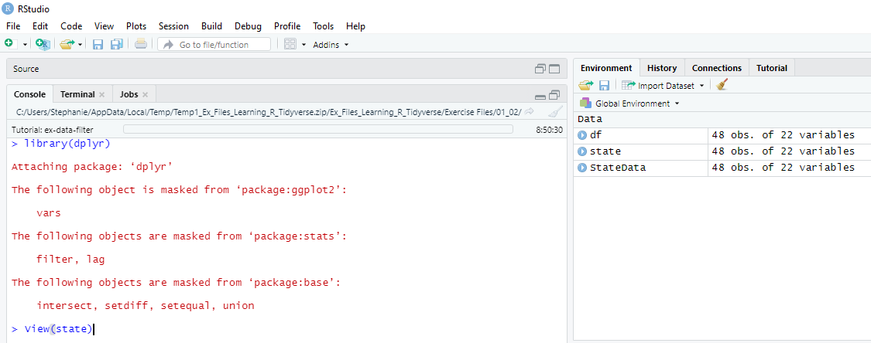

Calling Functions:
- Functions are orders to perform a task. For example: function_name()
- Two simple examples of function calls are:
  - view a dataset with view(dataset)
  - load a package with library(tidyr)
- Functions work sequentially; the filter() function demonstrates this well. It will check each test in order listed:
  - Example: filter(dataframe, logicaltest1 = 'answer', logicaltest2 ='answer')
  - 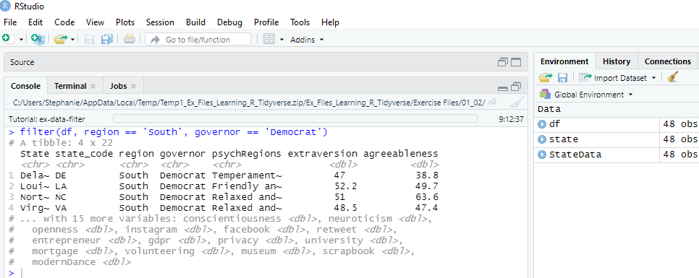

Manipulating Data Structures

Creating Data Frames
- There may be times you’ll have data that isn’t easily imported, and you will need to create your own data frame from your data.
- Your data frame will need a name, column names, and data. You can name it almost anything you’d like, then use the assignment operator ← and then we will say it will be a data frame by using data.frame()
- The values/data contained within the parentheses will begin with your column_name = At this point if the column will have multiple values we pull them together with c(1, ‘data’, 4) or whatever the values are for this column.
- Here is an example of creating a simple data frame, with multiple columns and values:
my_data ← data.frame(first_name = c('Steph', 'Ted', 'Denny') , last_name = c('Beal', 'Luther', 'Bronson') , lucky_number = c(13, 7, 3))
Note that:
- Characters have single or double quotation marks surrounding them and integers do not
- A comma separates each column and the characters inside the column are declared with c(data)
- All columns are within parentheses, so watch for that last "extra" parenthesis (skipping it will return an error)
- Example:
  - 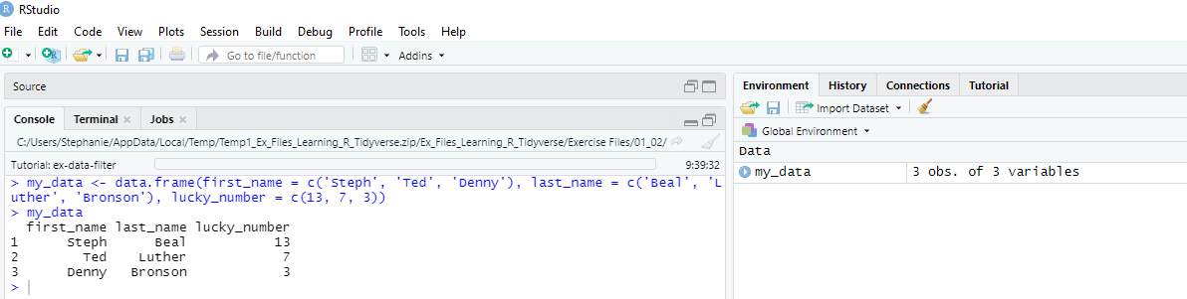

Tibbles
- Tibbles are data frames, with certain quirks, so to speak. They can make getting an overview of a large data set easier. It never changes the type of the inputs (for example, converting strings to factors) it never changes the names of variables, and it never creates row names. The first few rows are generally shown, one page at a time, and they show the data types of columns (int, char, etc.)
- Coercing a data frame to a tibble is as simple as: as_tibble(name_of_dataframe)
- Example: 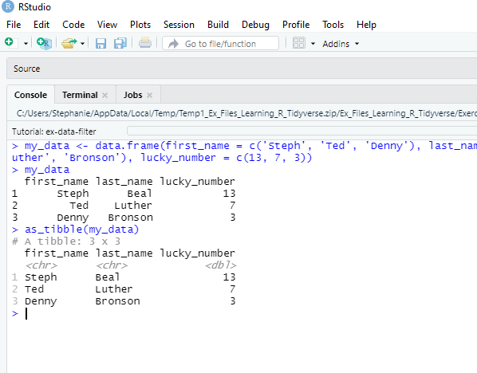

Filter
- filter() is used to subset a dataframe retaining all rows that meet your conditions; all conditions MUST be true.
- The format is: filter(dataframe, logicaltest1 = 'answer1', logicaltest2 = 'answer2')
- This returns a new dataframe to use or save. It DOES NOT overwrite the original (all dplyr functions do this).
- To "save" the output from filter assign it a name by adding → new_df_name to the end of the filter statement
- Comparison operators in filter: When you place a logical test inside of filter(), filter applies the test to each row in the data frame and then returns the rows that pass, as a new data frame.
- If filtering starts to get complicated, maybe make them explicit variables instead.
- Filter requires complete tests on both sides of operator
- Example: filter(data, test1 = 'answr1' | test1 'answr2')
- Using filter(data, test1 = 'answr1' | 'answr2') will not work:
  - 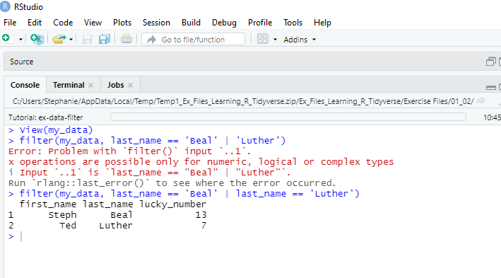

Pipes %>%
The purpose of the pipe operator is to send the output of one expression as the input to another. By "piping" you can write one line of code in place of several, and never have to store outputs in temporary variables, using the pipe to mean "and then". For example:
flights %>% select(arr_delay) %>% summarize(mean=mean(arr_delay))
…sends the flights data frame to the select command, pulling out only the arrival delays, then immediately sends those arrival delays to the summarize function to find the average arrival delay in the entire column. Using the pipe makes it much easier to code complex commands because you write them more like you speak English: Take the flights data frame AND THEN select arr_delay AND THEN calculate their mean. Pipes can be used to continue the sequence of "and then" statements.

Boolean operators - &(and), |(or), !(not), xor(exactly or)
- The %in% operator in R is used to identify if an element belongs to a vector or data frame.
- x %in% y will select every row where x is one of the values in y. This is value matching. Note in the image that 6 does not exist and is simply excluded/ignored. 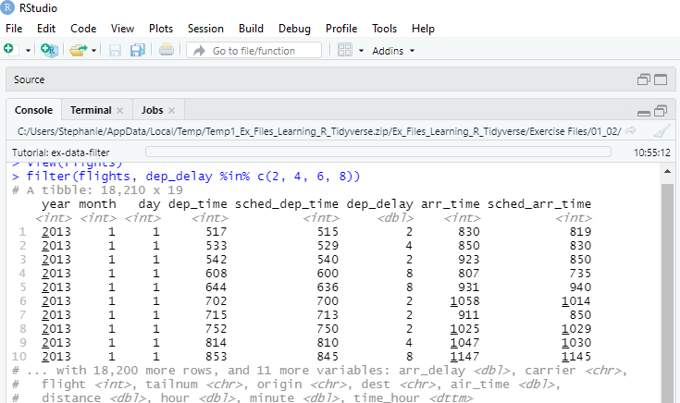
- Example:
  - filter(flights, dest %in% c('IAH', 'HOU'))
#DON'T FORGET QUOTES FOR CHAR VARIABLES!! This is excellent when you have multiple "or" searches in one column.
- Sometimes you can simplify complicated subsetting by remembering De Morgan’s law:
  - !(x & y) is the same as !x | y, and !(x | y) is the same as !x & y.
MISSING VALUES!!!! filter() excludes both false and NA values, you must ask for them explicitly.

Organizing Data
Organizing can be done several ways depending on your needs. Most of these types of functions are in packages like dplyr: = order(), arrange(), select() , filter() , mutate(), group_by(), and summarize()=. Some of these functions are described here. To use any of the functions below, be sure to activate dplyr using library(dplyr) before you begin.

Select
- This function is very helpful when you only need a few columns out of tens or hundreds. There are also several helper functions that can be used in it: starts_with(), ends_with(), contains() and so on
- ?select is helpful for more ways to use select()
- Example of using select() with a helper function:
  - select(flights, contains("delay"))
  - 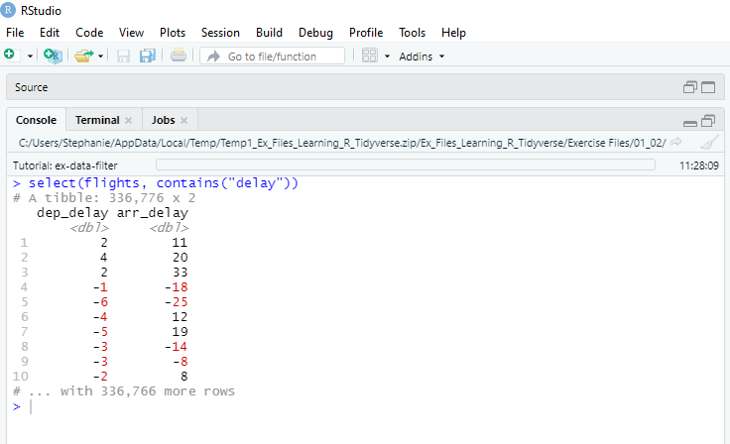

Arrange
- The arrange() function can arrange a columns variable ascending(default) or descending.
- This can be helpful for organizing by dates, dollar amounts, and other variables.
- Examples in image:
  - 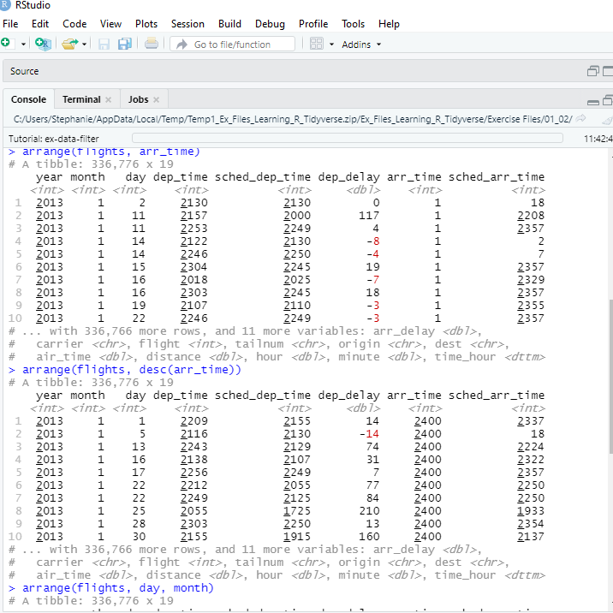

Mutate
- mutate() is especially helpful in that it’s used to create new variables. If a new variable (data column) needs to be added to a data frame, it can easily be done with mutate().
- Example: 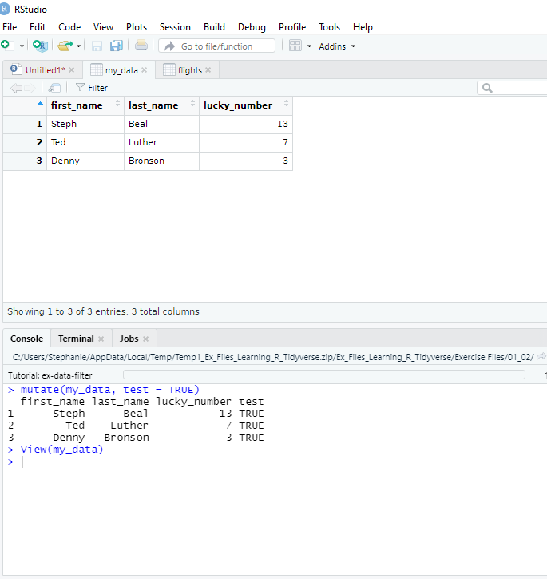

Miscellaneous

Plotting
- See Selena H's tutorial for details. It is excellent and thorough: Visualizing Data/Plotting

Help help()
- Typing a string or what you want help with in the parentheses will open an article in the Output window's Help tab if a help file exists.
  - Example: help("dplyr")
- ?data will do essentially the same thing as help()
  - Example: ?dplyr
- R Studio also contains a Help button in the top menu bar
- browseVignettes() will open a web page with all installed package vignettes. Typing in a package name inside the parentheses will return only that package's vignette.

Keyboard Shortcuts in RStudio
- Insert assignment operator Alt+- Option+-
- Insert pipe operator Ctrl+Shift+M Cmd+Shift+M
- Clear console Ctrl+L Ctrl+L
- Save active document Ctrl+S Cmd+S
- Run current line/selection Ctrl+Enter Cmd+Return
- Comment/uncomment current line/selection Ctrl+Shift+C Cmd+Shift+C
-- StephanieBeal - 25 Jan 2021
Edit | Attach | Subscribe | Print version | History: r5 < r4 < r3 < r2 | Backlinks | View wiki text | Edit wiki text | More topic actions
Topic revision: r5 - 22 Mar 2021, StephanieBeal

